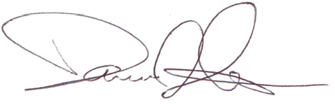
Trainer’s Signature
Dominic D'Imperio, Esq.
Director, Labor Relations
FEH BOCES
Jennifer Gorr
Successfully completed the 3-hour
TITLE IX OFFICER / COORDINATOR
(INVESTIGATIONS)
Training offered by NYS MASLA and sponsored by Franklin-Essex-Hamilton BOCES
Training Completed on September 26, 2025

TRAINING certificatION
JenniferGorrJenniferGorr

